5.Write a Pandas program to create a bar plot of the trading volume of Alphabet Inc.
stock between two specific dates.
Program:
import pandas as pd
import matplotlib.pyplot as plt
# Create Alphabet stock dataset
stock_data = pd.DataFrame({
"Date": pd.to_datetime([
"2024-01-01",
"2024-02-01",
"2024-03-01",
"2024-04-01",
"2024-05-01",
"2024-06-01",
"2024-07-01",
"2024-08-01"
]),
"Close": [140, 145, 150, 155, 160, 158, 165, 170],
"Volume": [
1000000, 1200000, 1100000, 1400000,
1300000, 1500000, 1600000, 1700000
]
})
# Select date range
start_date = "2024-01-01"
end_date = "2024-08-01"
filtered_data = stock_data[
(stock_data["Date"] >= start_date) &
(stock_data["Date"] <= end_date)
]
# Create bar plot
plt.figure(figsize=(10, 5))
plt.bar(
filtered_data["Date"].dt.strftime("%Y-%m"),
filtered_data["Volume"]
)
plt.title("Alphabet Inc. Trading Volume")
plt.xlabel("Date")
plt.ylabel("Trading Volume")
plt.xticks(rotation=45)
plt.tight_layout()
plt.show()
Output:
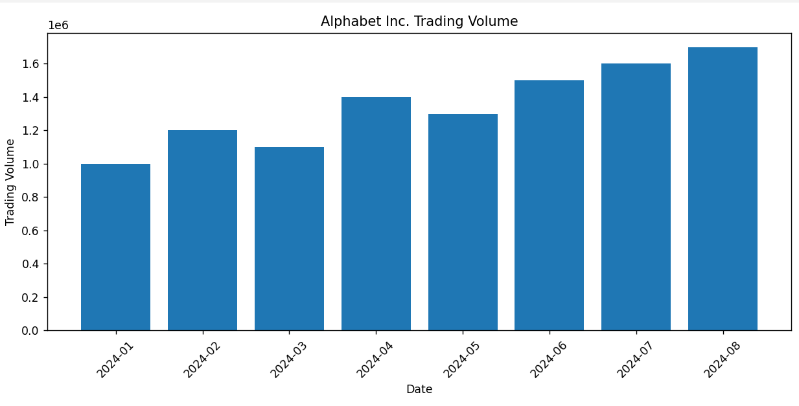
6.Write a Pandas program to create a scatter plot of the trading volume/stock prices of
Alphabet Inc. stock between two specific dates.
Program:
import pandas as pd
import matplotlib.pyplot as plt
# Create Alphabet stock dataset
stock_data = pd.DataFrame({
"Date": pd.to_datetime([
"2024-01-01",
"2024-02-01",
"2024-03-01",
"2024-04-01",
"2024-05-01",
"2024-06-01",
"2024-07-01",
"2024-08-01"
]),
"Close": [140, 145, 150, 155, 160, 158, 165, 170],
"Volume": [
1000000, 1200000, 1100000, 1400000,
1300000, 1500000, 1600000, 1700000
]
})
# Select date range
start_date = "2024-01-01"
end_date = "2024-08-01"
filtered_data = stock_data[
(stock_data["Date"] >= start_date) &
(stock_data["Date"] <= end_date)
]
# Create scatter plot
plt.figure(figsize=(8, 5))
plt.scatter(
filtered_data["Volume"],
filtered_data["Close"],
s=100
)
plt.title("Alphabet Inc. Trading Volume vs Stock Price")
plt.xlabel("Trading Volume")
plt.ylabel("Closing Stock Price")
plt.grid(True)
plt.tight_layout()
plt.show()
Output:

